Dutch Capitals Tour 2016
I love the Netherlands for no particular reason. Maybe it’s because it reminds me of my Norfolk childhood. Maybe it’s the Dutch friends we made as children during a swimmming club exchange, or maybe it’s just the Gouda and the Dutch acceptance of the bike as a valid mode of transport ? I don’t know, but for whatever reason, I was itching to go back over there and ride a randonneé. When I read about the DCT on YACF I was intrigued – until I read an account by an Israeli randonneur who completed the previous incarnation in 2012, whereupon I became hooked.
I followed the Facebook event, watched Leo Forster’s (aka mrpbp) website, asked Guus, the organiser, questions via email and found out the registration date. It was limited to 100 riders and I was determined to be one of them. I signed up in December almost as soon as it went live, expecting a PBP-style registration scrum. It wasn’t quite like that though. In the DCT’s second run, it ended up attracting just under 50 takers.
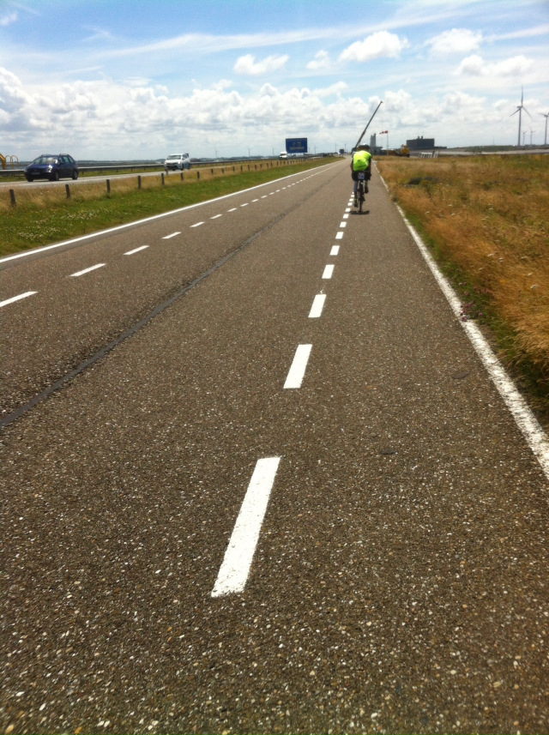
40 of us ultimately made it to the start in Zoetermeer near Delft, and left the club house at 10 am on Wednesday 13th July. Several well-wishers applauded us through the park and straight out onto the cycle paths that were to define this ride over the next three and a half days. Skirting Zoetermeer itself and heading south, we headed off towards Rotterdam via the lowest point in the Netherlands. Eager to avoid being boxed in to a slow group, I worked my way forward to where some quicker riders were already making their escape. I don’t know why I do this, because on a 1400K randonnee, there’s plenty of time to make time up, but off I went with my head down. My concious brain was firmly in its box this morning. Ever-darkening rain clouds were blowing in from the west and an animal instinct, fuelled by a truly massive hotel breakfast, was urging me on.
Before I knew it I was away, and out at the front of the large group. Now what? We’d barely covered 5k. Then a recumbent slipped past me and immediately took a wrong turn which sucked me off track too whilst my Garmin sorted itself out. Stabilising during turns or under high buildings or trees isn’t one of its strong points.
Heavy rain showers then came and went, we passed the lowest point in the Netherlands (-11m!) and rolled on past dikes (a.k.a. dijks), dunes and flood defences to a surprise control half way into the first 150k stage. Eventually we reached the first actual control at Middelburg – a petrol station (Esso) – and fuelled up. By this time I was alone at the front with a fellow Brit and two Dutch guys.
Zeeland
Not long after, it seems now, we were in Ossendrecht at a cafe having soup and a rather splendid ham, egg and toast salad. By now the weather had cleared up and the sun was setting in clear skies. I was loving it.
We were soon reduced to two – me and the Brit who was called Ray. Three Dutch riders had set off from the cafe independently and were pressing on. We saw them again briefly in the dark getting their stamps at another 24 hour Esso station at s’Hertogenbosch, before we all split again. We were ahead of the vague schedule I’d had in my head, having ridden 200k in 8 hours. It was a pace I couldn’t have imagined I’d be doing, but it felt easy, so I didn’t slack and just kept going. We fuelled up with Turkish pizza (who knew that was a thing?) and set off again, with the target of the border hills and the Vijlen sleep stop by 10am the next morning.
I don’t remember much about that night, but riding alongside the Meuse during the dawn was unforgettable. Ludicrously high leveés containing huge ships chugging towards the North Sea in rivers well above your head, make you question your brain’s lucidity after a night without sleep.
Before long we’d gone past Maastricht and were into the famous Dutch hills. (‘Famous’ because they defy the rest of the Netherland’s determination to be pan-flat). At the tourist trap of 3-landenpunt before it opened for business, we had our cards stamped by an unfortunate controller who’d been kicking his damp heels there in the mist and rain since 3am.
There was a relaxed stop in Vijlen shortly after, during which I demolished a large bowl of spag Bol and two coffees in short order, before freshening up and setting off again. It was starting to warm up and the landscape was flattening out again – not that the Dutch hills were that taxing. I found the Mendips and Cotswolds where I live to be more than adequate training for them.
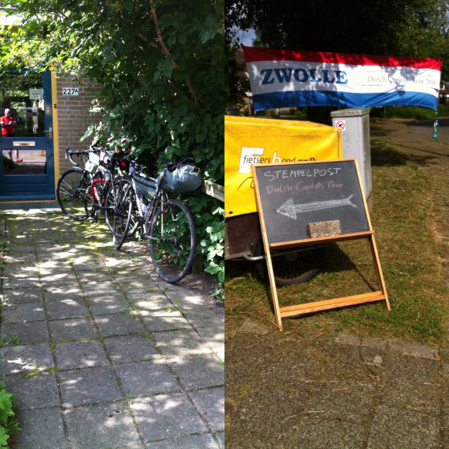
The next stage to Arnhem was not the most exciting stretch, quite frankly. Cycling alongside dual carriageway after dual carriageway was loud and unpleasant. We were here to ride between all the capitals, so we had to cover the distance and join the dots. We were blessed with a brief respite from the tedium however, when we were accosted by some Dutch Capitals ‘groupies’ near Roermond! Paul and Johanna ‘Fietst’, who’s riding the TCR as I write this, kindly gave us apricot cake and chatted. Their company was a welcome relief from the monotony. But we soon had our heads down again, cycling alongside more dual carriageways on paths of varying surface quality.
Bike paths in the Netherlands are frequently excellent, generally good, and only occasionally er, well, crap. Paved and cobbled sections often appear in towns and are uncomfortable after you’ve been sitting on a bike for 24hours +.
At Arnhem we crossed the two rivers and carried on towards the north and Zwolle, the next ‘sleep’ stop. I saw a Spoonbill in the marshes near Arnhem. What an odd looking bird that is. Its bill is literally the shape of a spoon.
We got there behind the impromptu schedule we’d come up with. Before, in the small hours, we’d crashed at the service station stop at Hengelo which had the comfiest coffee snug imaginable. The plushest, comfiest and cleanest vinyl covered bench seats one could could possibly want. It was practically a bed. We were spoilt by this and I knew it and couldn’t resist taking the opportunity to sleep there for 90 minutes. It wasn’t the first time we’d try and sleep in a 24hr service station, and despite me being convinced that people were standing nearby and talking about what we were doing (in Dutch, which I can barely understand), I slept well.
Zwolle !
Zwolle at 10 a.m. was great. It was the next manned control, complete with beds and home-cooked food. We were ushered into a communal flat in a block of low-rise 1960s/70s flats, offered showers, beds and endless food and drink. We must’ve been there nearly 90 minutes before we pushed off again. The controllers were keen to chat and of course Brexit reared its ugly head. Remainers in Britain aren’t the only ones worried about the fallout. We only saw one other rider there (Phillipe?) who was going to sleep at his mum’s, who lived round the corner!
Off we went again. The target was Leeuwarden – maybe by midnight. That’s when it all started to go a bit awry. I started to get the dozies on the way to Emmen. Ray never gets the dozies and didn’t want any delays, but I didn’t want to be a burden to anyone else. I started to wonder why we’d stuck together – why didn’t we just get on with our own rides at our own pace? We had some quick espressos and pressed on. Lack of sleep can certainly affect one’s judgement.
Whether this had an effect on what happened next I don’t know, but shortly after having to leave the bike path to follow yet another bike path diversion – this time not sign posted – a dog ran out from under a hedge and tried to bite Ray, who shouted a few expletives at it. This seemed to wind it up, and had the knock-on effect of slowing me down, so when the dog went for me, my legs were easy pickings.
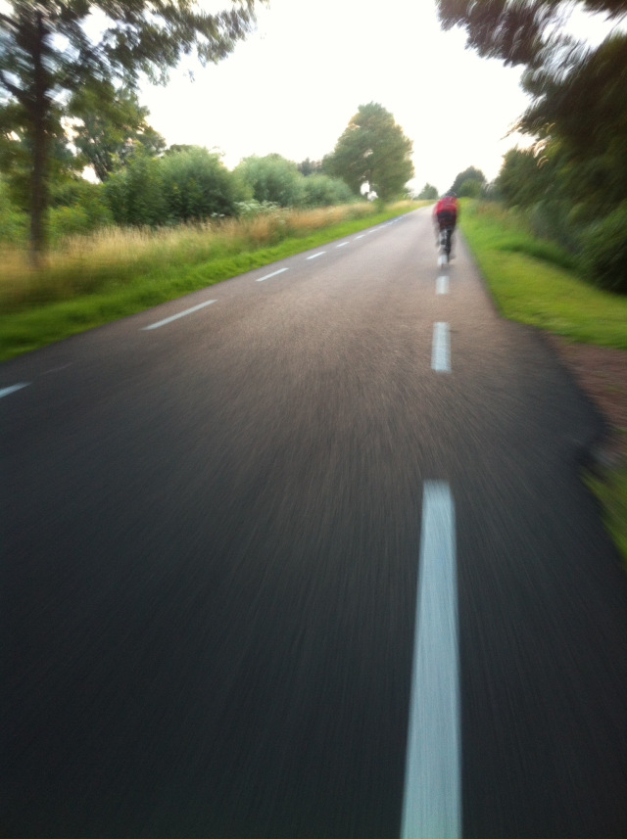
I was angry. I’d never been bitten whist riding before, and here I was having to deal with it 900K into a long ride in a foreign country. I saw red, but whilst Ray went off to confront the householder who owned it, the dog had another go at him. A driver stopped to help us and then the owner arrived back at his house. He couldn’t speak English and didn’t believe that his dog had bitten me at first – until he saw the bloody teeth marks in my leg.
To his credit he gave me his address and offered to call a Doctor, but this was a randonneé and I’d had 90 minutes sleep in 55 hours. I wasn’t thinking clearly, so I wasn’t going to stop if I could get away with it. I cleaned and dressed the wound the best I could and crossed my fingers. My anger then fuelled the next 60K at least. I dragged Ray through a hastily routed detour and took no dissent. We re-joined the gps route and headed off towards Groningen.
After another service station (Esso again) we left Groningen and headed out north towards Leeuwarden. The countryside is reminiscent of Norfolk, east of Norwich, where I grew up. By now I’d moved on from the day’s unpleasantries and was enjoying the balmy nightfall amongst the flat landscape, rivers, reeds and wildlife. I saw a Stork, which was a first, and soon after Ray was suggesting a another massive feed to see us through the night.

Dusk in Friesland
We eventually found a pizza restaurant open in a remarkably sleepy town called Buitenpost which seemed fairly dead for 10pm. The proprietor mocked my Englishness because of Brexit and then ripped us off for water. Hey ho – I live and learn! I should’ve asked the price first … Then my Garmin went nuts and stopped recording until I realised at the next scheduled stop in Leeuwarden.
Leeuwarden’s 24 Hour Esso garage was nothing like the previous night’s 24 Hour Esso garage. It was a busy Friday night. Inebriates and local characters popped in and out, finding the presence of bikes and soiled randonneurs intensely interesting. It quickly became clear that I wasn’t going to get any sleep there, so I fuelled up on moar espresso and got ready to go. Ray had other ideas and stayed to sleep. How he managed it there, I have no idea, but apparently he did. A Belgian rider also appeared and sloped off out back to sleep in a support vehicle ! That just seems wrong to me. Why not do it properly by slumming it on the floor of a 24 hours Esso garage amongst a milieu of drunks and deadbeats ? Ok, maybe I just answered that ….
I left Leeuwarden and decided to keep going and confront the dreaded dijk accross the mouth of the Ijsselmeer. Tal’s write up of the previous ride in 2012 had mentioned this experience in unflattering terms. He hadn’t particularly enjoyed it. During my preparation, I’d noticed that the dijk went on for over 30K. It was straight, flat and windswept. I’d been dreading it and just wanted to get it over with. Before I got there though, I got a bad bout of the dozies. No surprise I suppose, after having had only 90 minutes sleep in what was now 64 hours. As dawn was beginning to break, I found a secluded car park, got out my emergency foil bivvy bag and slept soundly for just over an hour.
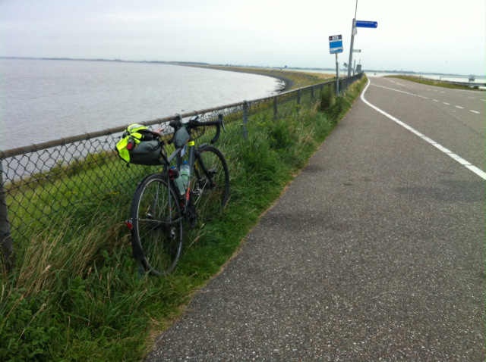
The start of a dreaded dijk …
Dijks – ah, the sweet torture. If you’ve never ridden along one and think riding in the Netherlands is easy because of the lack of hills, think again. Crossing the mouth of the Ijsselmeer was, at best, a tedious chore. I’d never cycled towards vanishing point before, but that’s exactly what I had to do for at least the next hour and a bit. I fixed on a sustainable minimum speed into that headwind and kept my head down. Time for some music. I plugged myself into my ipod and tried not to look up. Once it was all over, I was practically elated. That was it for the dijks I thought. What a deluded fool …
At the next sleep stop at a cycling club / athletics track at Hoorn, I met Ray again, who’d overtaken me whilst I’d slept in the car park. I mentioned my dog adventure to a concerned controller who sensibly suggested tetanus jabs and seeing a doctor, but as it wasn’t hurting that much, I gave the bite little thought. I was focussed on getting back to Zoetermeer by midnight and pressed on with Ray again as soon as we’d both fuelled and freshened up.
Another dijk had been mentioned by the Hoorn volunteers. It was almost 30k again, but this time it came with a tailwind. It was quickly over and done with, although my tubeless tyre started to spray out sealant again – something it started doing on the very day I was due to leave the UK. Great timing. I held the hole at bottom dead centre and hoped for the best. It seemed to seal itself and off I went again towards Lelystad in Flevoland – the entirely reclaimed province. I was alone again because Ray had been struck down by the dozies. Thinking he’d been right behind me, I hadn’t noticed for a while. It sounds callous now, but I just carried on, assuming that he’d just had to rest. I’m not sure I was thinking straight quite honestly.
At the end of the dijk, there was a lock and a swing bridge which stopped traffic to let shipping through just as I got there. As I waited, Ray reappeared alongside me after his nap. We set off after the bridge swung back and gradually found ourselves atop another dijk heading south west towards Amsterdam which was just visible in the far distance. With the Markemeer off to the right and marshes to the left, we were completely exposed to the nagging headwind and kept peddling into it for the next hour or God knows how long. Amsterdam – its skyline clearly visible on the horizon – just didn’t seem to get any closer. I played with the map scale on my Garmin, just to see the landscape change on the map. Eventually this purgatory had to end and finally we headed off through Almere on the way off Flevoland and onto Utrecht.
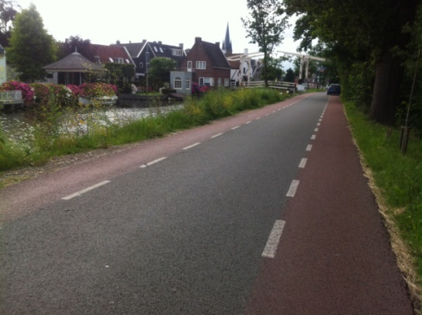
Back into an old province, we were amongst canals, fortified towns (beautiful Naarden), windmills and Hydrangeas. Forget the Tulips that the Dutch are famous for by the way – the flower I saw most was the Hydrangea, and lots of them, in full, beautiful bloom. My cache battery started playing up at this point and I decided to drop out and find some AAs so I could charge things with a spare USB charger which takes 4x AAs. I suggested to Ray that he needn’t wait, and he didn’t need any encouragement. He was off like a shot, while I looked for batteries on a late Saturday afternoon close to closing time. I eventually found some in a Dutch Lidl, or was it an Aldi – I can’t remember. It was one of them.
Next thing, once I’d sorted my charging out, I got back on the route and was loving it. I spent a blissful time pootling alongside well-maintained canals, immaculate gardens and through the history of Utrecht and North Holland. This is where much of the wealth of the 17th & 18th century Dutch Republic seemed to have been spent – on impressive dwellings.Somewhere in the provinces of Utrecht or North Holland …At yet another Tank Station (Texaco) in Utrecht – I bumped into Ray again. We were taking too long at controls, he said, so it was time to press on … off towards Amsterdam and past yet more gorgeous period houses of the well-healed in the wealthier suburbs. In Amsterdam itself we split again briefly after I made it clear that I wasn’t ready to go and that he should press on. I’d realized I’d get to the Arriveé at midnight-ish and I’d need some decent sleep. I needed to book a hotel room. I stopped, made a call and then got going again.
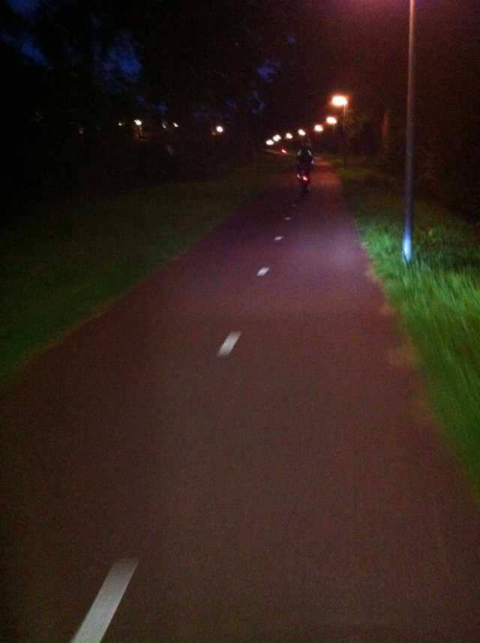
And then it was dark, or getting dark. I sped along bike paths towards Haarlem and then on towards the Hague (Den Haag). Ray and I made contact somewhere and we bowled along together again, although we wandered off track a few times for reasons I only now understand fully. Different Garmins hold different amounts of route data – depending upon the track source. My 810’s Basecamp-imported route could put me on a particular side of the road and hugged corners and junctions very clearly. Ray’s route wasn’t as accurate it seems, which was especially a problem in built up areas. The result was that we found ourselves near midnight in a deep dark woodland in the middle of Den Haag. GPS units don’t work well under tree cover. You may have noticed this yourself. We floundered about for way too long trying to find our way out. Only 15K from the Arriveé and we were lost in the middle of a wood in the midst of the capital of the Netherlands! It was just absurd and way too much for my sleep-deprived mind to cope with. I have to admit I lost it somewhat.
Not far now …
One final checkpoint stamp in Den Haag itself and we split again. I wanted to just make sure that the hotel would be manned and could cope with my late, stinky appearance …. I set off on the final 11K stint on my own and took it all in. 1400K in 86 hours. Not bad. But I was longing to get into a comfy bed and sleep the dreamless sleep of the randonneur. I was also looking forward to a shower. I stank (have I mentioned that yet?) and was caked in road grime. The paths and housing estates gave way to more canal side paths, blocks of flats and parks, and before I knew it I was back in the Zoetermeer 77 club house. Where was Ray ? He set off from Den Haag before me. Had he gone already ? Just as I was handing in my brevet, his face appeared at the window. His Garmin had lead him astray again. But there we were – at the hushed, subdued Arriveé getting our final stamps at just after midnight. No Champagne celebration, just tired reflection on the previous 3 1/2 days pedalling.
What a ride. I’d recommend it. It’s more X-rated than PBP-like due to the numbers of people involved, but that makes it rather special I think. Bumping into another randonneur on the same ride as you is more of a unexpected treat – especially because you’ve probably met them and spoken to them already. The dijks have to be seen – and cycled on – to be believed. If it runs again in 2020, I hope I’ll be there.
Here it is on Strava: https://www.strava.com/activities/645096426

